Issues to fix:
1. In the update password page need to add the current password field so that we can verify and proceed with resetting password.
2. In the verify payment page I cant see the numbers entering and other error as well.
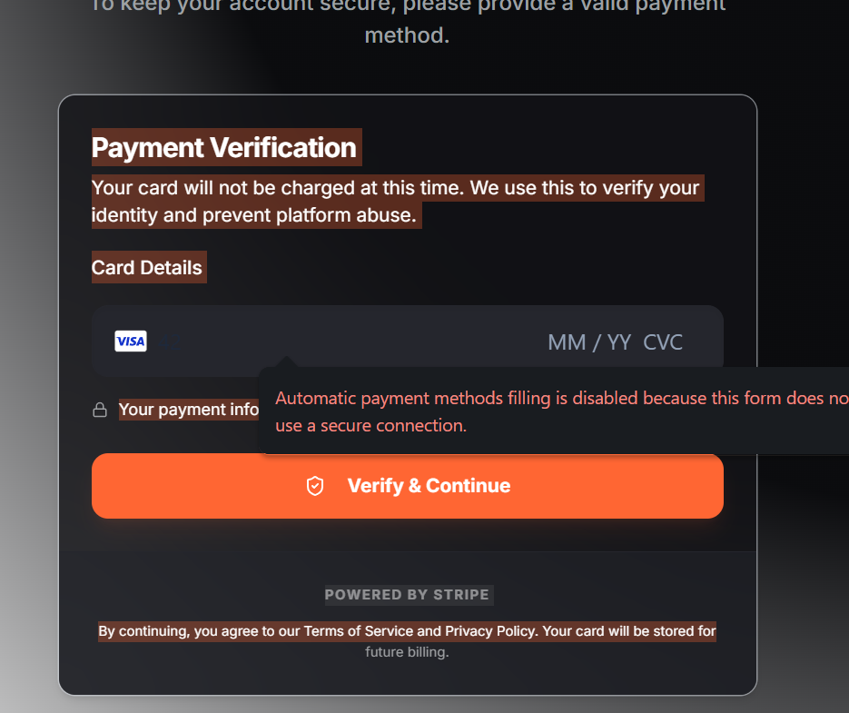

3. Here is the catch when we are hosting locally I see the user can access the page by just adding the extension to the url like /verify-payment.
and when verifying getting this error.
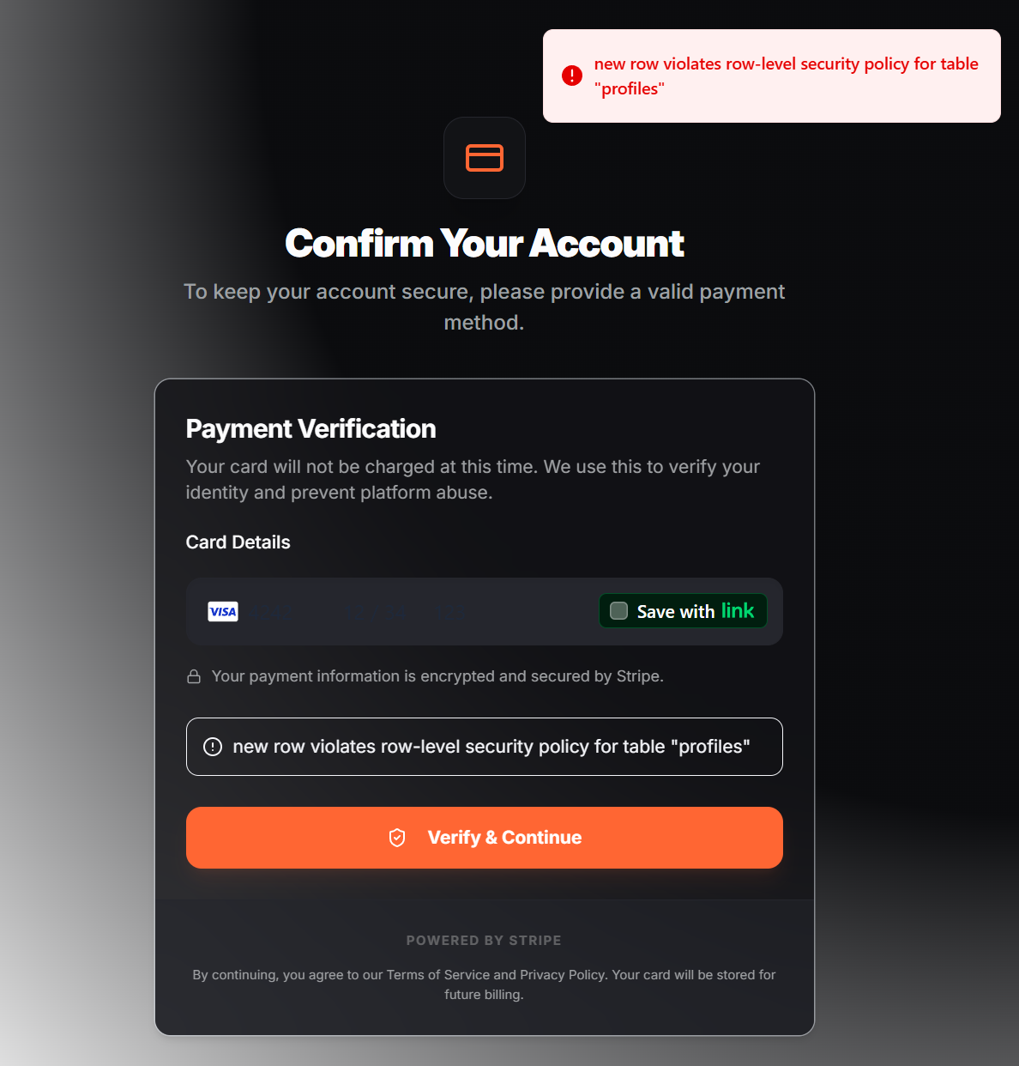

4. here is another catch I delete the oraganiastion and user and after that with out inviting the deleted user can login with they login details and can do the onboarding processing live verification and onboarding..

